Methods - experimental design
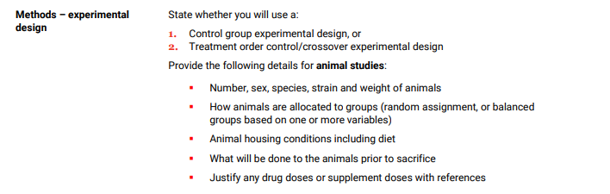

- Control group experimental design
- Info about the animal models
- Number – 40 mice altogether (10 mice each)
- Sex – male mice
- Balanced groups based
- 6-8 days follow up
- Percentage area calculation – quantifying data from IHC

Negative control – no primary antibody (just add the secondary antibody) in IHC – should have no staining
(Secondary negative control – just add the primary antibody)

- Do the staining and unblind..blinded up to that point - avoiding biases

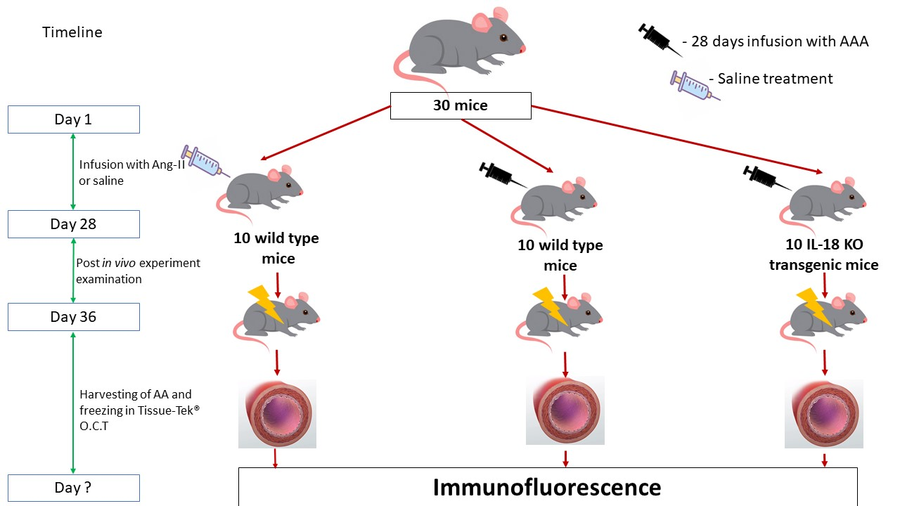
We will be conducting a control, balanced group-based experiment using healthy male mouse models. All animal procedures of our experiment are approved by the La Trobe Animal Ethics Committee (AEC 16-93).
20 wild type mice and 10 genetically modified (IL-18 knocked out) mice acquired were bred-in captivity at La Trobe Animal Research Training Facility.
In order to proceed with our experiment, we need to induce AAA in our mouse models.
There are 3 common ways to induce AAA in mouse models. Through either adventitial exposure to calcium chloride, transient perfusion of elastase into the infrarenal aorta or through chronic subcutaneous infusion of Ang II (Davis et al., 2019; Lu et al., 2017).
We will be using the Ang-II method.
Mice will be anaesthetized and 10 transgenic mice and 10 of 20 WT will be implanted with a subcutaneous osmotic minipump containing Ang-II(1.44mg/kg) (Alzet model 2004, USA). And they will be infused with Ang-II over a period of 28 days in order to induce hypertension and therefore, make them prone to AAA.
The rest will be implanted with a subcutaneous osmotic minipump containing 0.9% saline.
Following the treatment period, all 30 mice will be closely examined for eight days. Mice will be housed individually in ventilated chambers with free access to regular chow and water.
At the end of the in vivo treatment period, all WT and transgenic mice will be killed through CO2 asphyxiation and their abdominal aortas will be freshly harvested and snap frozen in Tissue-Tek® O.C.T (Sakura Finetek, Japan) in order to perform immunofluorescence on their cross sections.
Results from immunofluorescence will be used to determine the degree of macrophage infiltration in each group of mouse models.

Lu, H., & Daugherty, A. (2017). Aortic aneurysms. Arteriosclerosis, thrombosis, and vascular biology, 37(6), e59-e65.
Davis, F. M., Daugherty, A., & Lu, H. S. (2019). Updates of Recent Aortic Aneurysm Research. Arteriosclerosis, thrombosis, and vascular biology, 39(3), e83-e90.

Questions
Exact number of mice – 6/7/8???
Transgenic mice - Gene that codes for IL-18 knocked out?
Ang II subcutaneous infusion?
Saline will be given over the same period of time?
How are these mice killed? Isoflurane inhalation overdose?
Animal housing conditions including diet?
Weight of the animals?
What is the dose of Ang-II (0.7 mg/kg) and saline 0.9%? And why? References?
Why do we choose the Ang-II infused mice (out of other sorts of mouse AAA models – elastase infused, and calcium chloride infused)

Lu, H., & Daugherty, A. (2017). Aortic aneurysms. Arteriosclerosis, thrombosis, and vascular biology, 37(6), e59-e65.
Davis, F. M., Daugherty, A., & Lu, H. S. (2019). Updates of Recent Aortic Aneurysm Research. Arteriosclerosis, thrombosis, and vascular biology, 39(3), e83-e90.

Figure 1. Representation of macrophage infiltration in blood vessel adventitia of each type of mouse models. Immunofluorescence staining of the aortic cross sections of Ang II treated (A) IL-18 KO mice and (B) WT mice versus saline treated (C) WT mice. Green embodies the elastin layer in vessel walls whereas orange represents the macrophages infiltrating the vessel walls.
Figure 2. A comparison between macrophage infiltration in vessel walls of each type of mouse models. The data is represented as aortic cross sections of (A) all WT mice versus IL-18 KO mice (B) WT mice with no AAA versus IL-18 KO mice and (C) WT mice with developed AAA mice versus IL-18 KO mice. The data are presented as mean ± SD (n > 4). *Significant difference, p < 0.05

