**a) NCF Images**

Insert your labelled NCF images here – one after Ponceau S staining and one after AP detection. Each lane should be labelled to indicate the sample loaded, although it will be too hard to include this information above each lane. Therefore, you should label the lanes with numbers and then include a figure legend with sample descriptions.

After Ponceau S staining

1 2 3 4 5



|  |  |
| --- | --- |
| **Lane number** | **Sample description** |
| 1 | Crude mammalian cell extract |
| 2 | Crude bacterial (E.coli) extract |
| 3 | Purified IgY |
| 4 | Purified IgY |
| 5 | SeeBlue 2 Plus MW markers |

NCF after AP detection

1 2 3 4 5

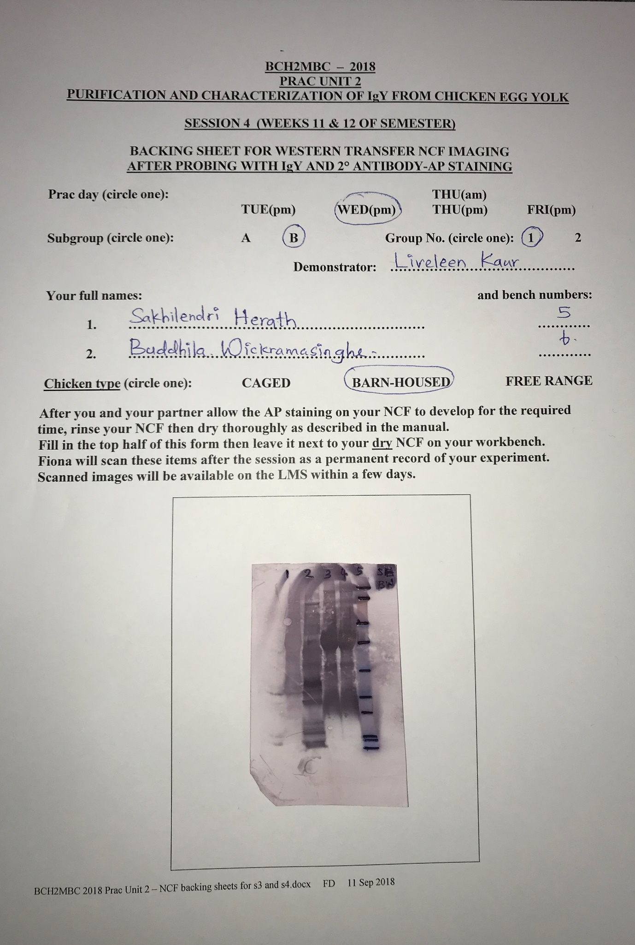

|  |  |
| --- | --- |
| **Lane number** | **Sample description** |
| 1 | Crude mammalian cell extract (heart or skeletal muscle) |
| 2 | Crude bacterial (*E. coli*) cell extract |
| 3 | Purified IgY |
| 4 | Purified IgY |
| 5 | SeeBlue 2 Plus MW markers |

(2 marks)

**b) Results Description**

Write 100-150 words describing your results, using the following questions as a guide:

What did you see in the lanes containing the mammalian and bacterial cell extract samples on your own NCF after AP detection?

What did you see in the lanes containing the IgY samples on your own NCF after AP detection? Was this consistent with what you expected to see, and what did these results tell you?

There are bands visible in the lane containing bacterial cell extract. However, no bands are visible (slightly visible) in the lane containing mammalian cell extract.

3 bands are visible in each lane containing IgY as expected. 3 bands suggest that the purified IgY contains both reduced and non-reduced peptides. The first bulky band visible in lane 3 and 4 represents the non-reduced (2 heavy chains+ 2 light chains) IgY, second band in both lanes 3 and 4 represents the two light chains of IgY whereas the third band at the bottom of both the lanes represents the two heavy chains of IgY. Since a heavy purple colour appears in band 1 and 3, it can be suggested that the secondary antibody (containing the AP enzyme bound to it) has bound to the Fc portion (heavy chains) of the primary antibody.

(2 marks)

**b) Discussion**

Write a 200-250 word discussion, using the following questions are a guide:

After looking at a representative number of NCFs from the entire class, probed with IgY purified from all three categories of laying chicken (caged, barn-housed and free-range), can you draw any conclusions about the breadth of IgY antibody responses observed in the three categories of laying chicken? Discuss possible reasons for the differences observed (if any).

If there are dark purple bands in both lanes containing mammalian and bacterial cell extracts, the breadth of the IgY antibody is free-range. If there are bands that are neither too dark nor too light in lanes containing mammalian and bacterial cell extracts (there may be no bands visible in some lanes), the breadth of the IgY antibody is barn-housed. If there are faint, light bands in lanes containing mammalian and bacterial cell extracts (there maybe no bands visible in some lanes), the breadth of the IgY antibody is caged

Generally, more dark bands are visible in mammalian and bacterial cell extracts in free range chickens while lightest bands are visible in caged chickens suggesting that the free-range chickens have been exposed to more pathogens than the caged chickens and therefore, free range chickens have produced antibodies that are compatible with antigens in both mammalian and bacterial cell extracts. Primary antibodies bind (containing the secondary antibody + AP enzyme bound to it) to their compatible antigens. The darker the colour of the band the more antibodies bound to their antigens the cell extracts contain. If there are lanes containing no bands (possibly caged and barn-housed chicken types), it can be suggested that that particular type of chickens have not been exposed to that pathogen (either *E. coli* or mammalian) and therefore they haven’t produced IgY antibodies that are compatible to bind with the antigens of that particular cell extract.

(4 marks)